**Московский государственный технический**

**университет им. Н.Э. Баумана.**

Факультет «Информатика и системы управления»

Кафедра ИУ5. Курс «Парадигмы и конструкции языков программирования»

Отчет по Домашнему заданию

«Арканоид»

|  |  |  |
| --- | --- | --- |
| Выполнил:  Макеева Е. А.  ИУ5-31Б |  | Проверил:  Нардид А. Н. |
| Подпись и дата: |  | Подпись и дата: |

В рамках проекта осуществлено программирование видеоигры «Арканоид» на языке Java, где игрок контролирует небольшую платформу-ракетку, которую можно передвигать горизонтально от одной стенки до другой, подставляя её под шарик, предотвращая его падение вниз. Удар шарика по кирпичу приводит к разрушению кирпича.

**Внешний вид:**

Заставка игры (просмотр заставки сопровождается звуковым фрагментом, для пропуска заставки игроку требуется нажать на любую клавишу на клавиатуре или кнопку мыши):

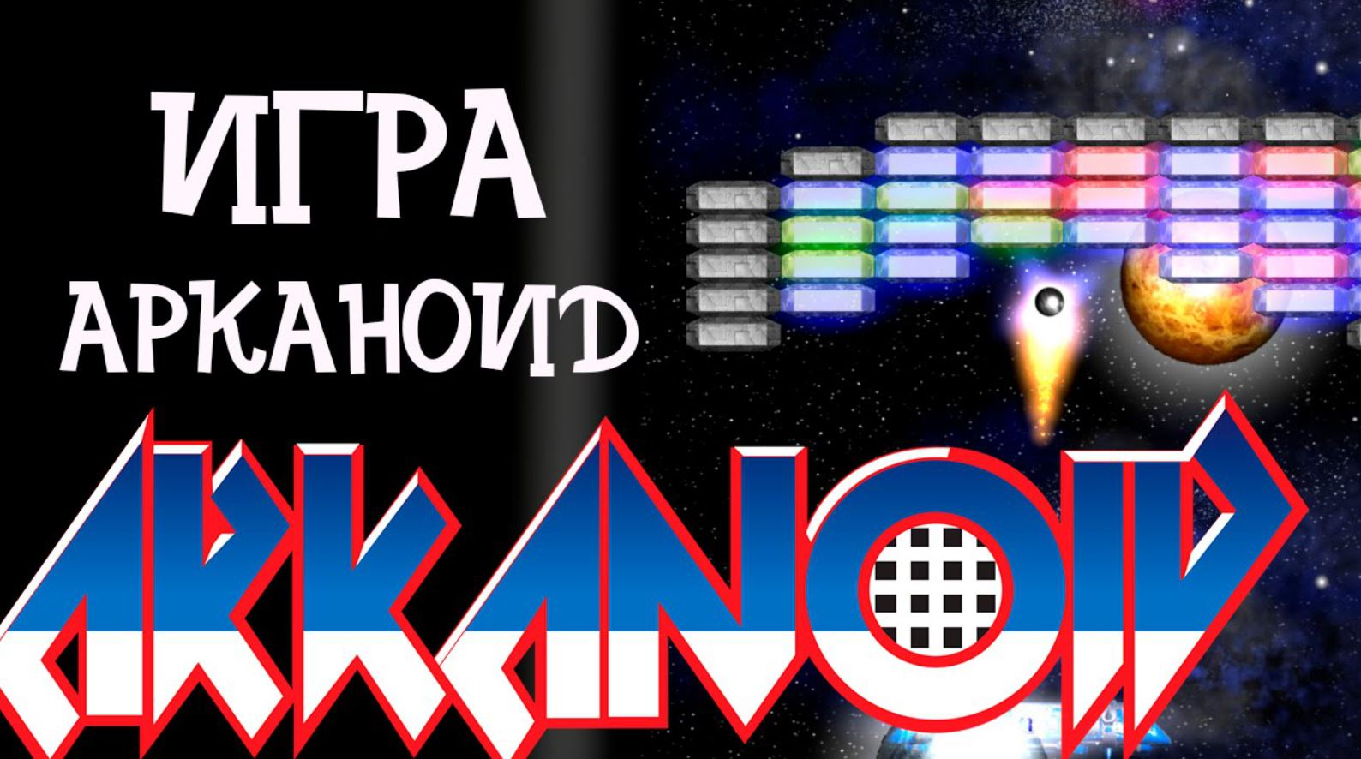

Основное игровое поле:

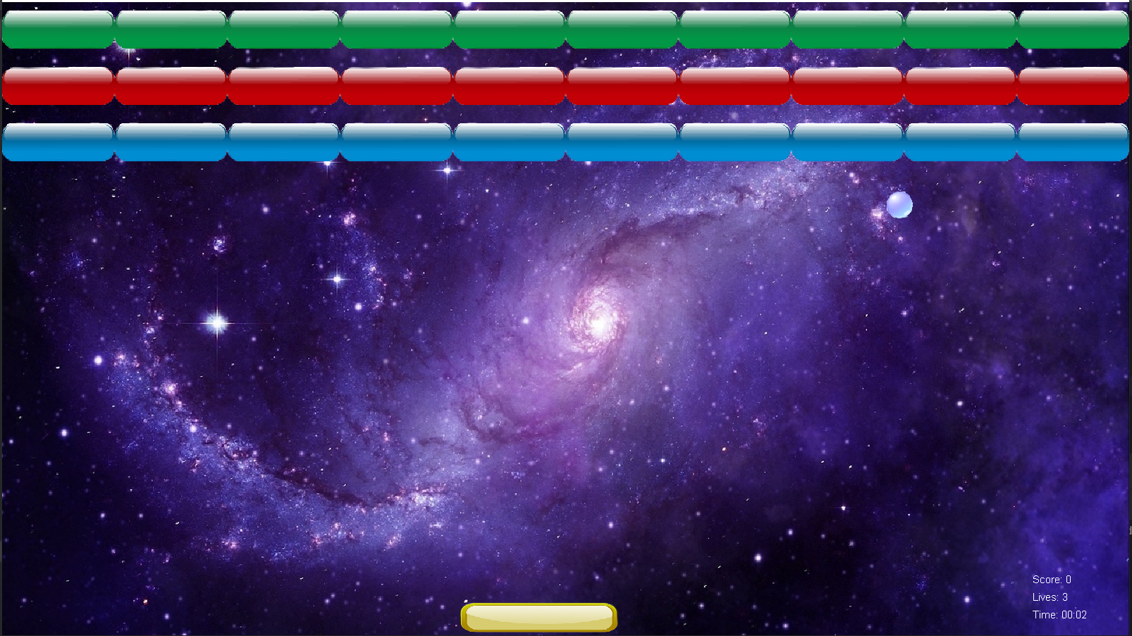

Экран «You win»

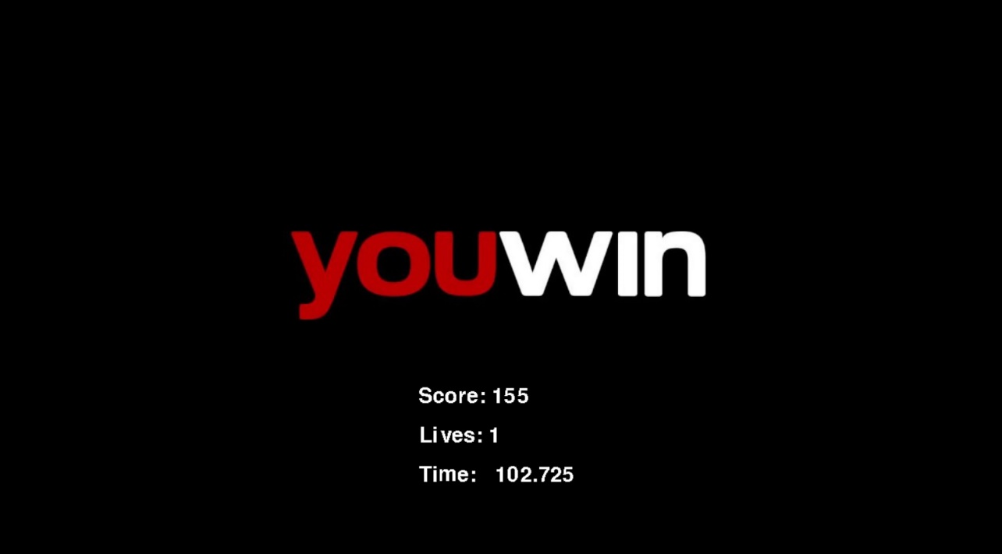

**Экран «Game over»**

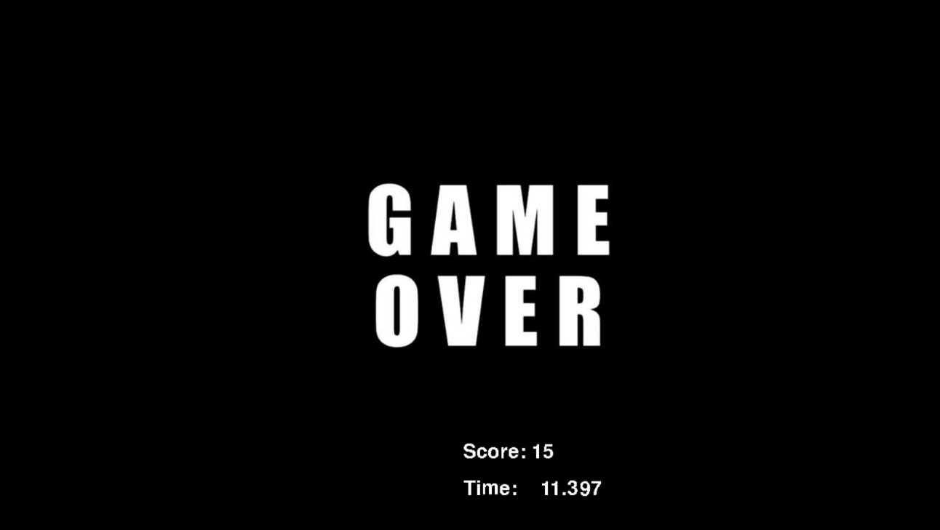

import javax.imageio.ImageIO;  
import java.awt.*;  
import java.awt.image.BufferedImage;  
import java.io.File;  
import java.io.IOException;  
  
public class Ball {  
 private int x, y, diameter = 30;  
 private int dx = 12, dy = -12;  
 private BufferedImage image;  
 private MainGame mainGame;  
  
 public Ball(int x, int y, MainGame mainGame) {  
 this.x = x;  
 this.y = y;  
 this.mainGame = mainGame;  
 loadImage();  
 }  
  
 private void loadImage() {  
 try {  
 image = ImageIO.*read*(new File("data/ball.png"));  
 } catch (IOException e) {  
 e.printStackTrace();  
 }  
 }  
  
 public void move() {  
 x += dx;  
 y += dy;  
  
 if (x < 0 || x > 1280 - diameter) {  
 dx = -dx;  
 }  
 if (y < 0) {  
 dy = -dy;  
 }  
 if (y > 720 - diameter) {  
 y = 720 - diameter;  
 dy = -dy;  
 mainGame.lives--;  
 if (mainGame.lives <= 0) {  
 mainGame.endGame();  
 }  
 }  
 }  
  
 public void reverseY() {  
 dy = -dy;  
 }  
  
 public Rectangle getBounds() {  
 return new Rectangle(x, y, diameter, diameter);  
 }  
  
 public void draw(Graphics g) {  
 g.drawImage(image, x, y, diameter, diameter, null);  
 }  
}

import javax.imageio.ImageIO;  
import java.awt.*;  
import java.awt.image.BufferedImage;  
import java.io.File;  
import java.io.IOException;  
  
public class Block {  
 private int x, y, width = 128, height = 64;  
 private BufferedImage image;  
  
 public Block(int x, int y, String imagePath) {  
 this.x = x;  
 this.y = y;  
 loadImage(imagePath);  
 }  
  
 private void loadImage(String imagePath) {  
 try {  
 image = ImageIO.*read*(new File(imagePath));  
 } catch (IOException e) {  
 e.printStackTrace();  
 }  
 }  
  
 public Rectangle getBounds() {  
 return new Rectangle(x, y, width, height);  
 }  
  
 public void draw(Graphics g) {  
 g.drawImage(image, x, y, width, height, null);  
 }  
}

import javax.imageio.ImageIO;  
import java.awt.*;  
import java.awt.image.BufferedImage;  
import java.io.File;  
import java.io.IOException;  
  
public class Player {  
 private int x, y, width = 200, height = 40;  
 private BufferedImage image;  
  
 public Player(int x, int y) {  
 this.x = x;  
 this.y = y;  
 loadImage();  
 }  
  
 private void loadImage() {  
 try {  
 image = ImageIO.*read*(new File("data/player.png"));  
 } catch (IOException e) {  
 e.printStackTrace();  
 }  
 }  
  
 public void moveLeft() {  
 if (x > 0) x -= 15;  
 }  
  
 public void moveRight() {  
 if (x < 1280 - width) x += 15;  
 }  
  
 public void update(boolean leftPressed, boolean rightPressed) {  
 if (leftPressed) {  
 moveLeft();  
 }  
 if (rightPressed) {  
 moveRight();  
 }  
 }  
  
 public Rectangle getBounds() {  
 return new Rectangle(x, y, width, height);  
 }  
  
 public void draw(Graphics g) {  
 g.drawImage(image, x, y, width, height, null);  
 }  
}

import javax.swing.*;  
import java.awt.*;  
import java.awt.event.KeyAdapter;  
import java.awt.event.KeyEvent;  
import java.awt.image.BufferedImage;  
import java.io.File;  
import java.io.IOException;  
import javax.imageio.ImageIO;  
  
public class StartScreen extends JPanel {  
 private BufferedImage backgroundImage;  
  
 public StartScreen() {  
 try {  
 backgroundImage = ImageIO.*read*(new File("data/fon_start.jpg"));  
 } catch (IOException e) {  
 e.printStackTrace();  
 }  
  
 setPreferredSize(new Dimension(1280, 720));  
 setFocusable(true);  
 addKeyListener(new KeyAdapter() {  
 @Override  
 public void keyPressed(KeyEvent e) {  
 openMainGame();  
 }  
 });  
 }  
  
 private void openMainGame() {  
 JFrame topFrame = (JFrame) SwingUtilities.*getWindowAncestor*(this);  
 topFrame.dispose();  
  
 JFrame gameFrame = new JFrame("Main Game");  
 MainGame gamePanel = new MainGame();  
 gameFrame.add(gamePanel);  
 gameFrame.pack();  
 gameFrame.setDefaultCloseOperation(JFrame.*EXIT_ON_CLOSE*);  
 gameFrame.setVisible(true);  
 }  
  
 @Override  
 protected void paintComponent(Graphics g) {  
 super.paintComponent(g);  
 if (backgroundImage != null) {  
 g.drawImage(backgroundImage, 0, 0, getWidth(), getHeight(), null);  
 }  
 }  
}

import javax.swing.*;  
import java.awt.*;  
import java.awt.event.*;  
import java.awt.image.BufferedImage;  
import java.io.File;  
import java.io.IOException;  
import javax.imageio.ImageIO;  
import java.util.ArrayList;  
import java.awt.event.ActionEvent;  
  
public class MainGame extends JPanel implements ActionListener, KeyListener {  
 private Timer timer;  
 private Ball ball;  
 private Player player;  
 private ArrayList<Block> blocks;  
 private int score = 0;  
 public int lives = 3;  
 private BufferedImage backgroundImage;  
 private long startTime;  
  
 private boolean leftPressed = false;  
 private boolean rightPressed = false;  
  
 public MainGame() {  
 setPreferredSize(new Dimension(1280, 720));  
 setBackground(Color.*BLACK*);  
 setFocusable(true);  
 addKeyListener(this);  
  
 timer = new Timer(50, this);  
 timer.start();  
  
 ball = new Ball(620, 600, this);  
 player = new Player(512, 680);  
 blocks = new ArrayList<>();  
 initializeBlocks();  
 loadBackgroundImage();  
  
 startTime = System.*currentTimeMillis*();  
 }  
  
 private void loadBackgroundImage() {  
 try {  
 backgroundImage = ImageIO.*read*(new File("data/fon.jpg"));  
 } catch (IOException e) {  
 e.printStackTrace();  
 }  
 }  
  
 private void initializeBlocks() {  
 for (int i = 0; i < 1280; i += 128) {  
 blocks.add(new Block(i, 0, "data/block_green.png"));  
 blocks.add(new Block(i, 64, "data/block_red.png"));  
 blocks.add(new Block(i, 128, "data/block_blue.png"));  
 }  
 }  
  
 public void actionPerformed(ActionEvent e) {  
 ball.move();  
 player.update(leftPressed, rightPressed);  
 checkCollisions();  
 repaint();  
 }  
  
 private void checkCollisions() {  
 for (Block block : blocks) {  
 if (ball.getBounds().intersects(block.getBounds())) {  
 blocks.remove(block);  
 ball.reverseY();  
 score += 10;  
 break;  
 }  
 }  
  
 if (ball.getBounds().intersects(player.getBounds())) {  
 ball.reverseY();  
 }  
  
 if (blocks.isEmpty()) {  
 winGame();  
 }  
 }  
  
 public void endGame() {  
 JFrame topFrame = (JFrame) SwingUtilities.*getWindowAncestor*(this);  
 topFrame.dispose();  
  
 JFrame gameOverFrame = new JFrame("Game Over");  
 JPanel panel = new JPanel() {  
 private BufferedImage backgroundImage;  
  
 {  
 try {  
 backgroundImage = ImageIO.*read*(new File("data/fon_end.jpg"));  
 } catch (IOException e) {  
 e.printStackTrace();  
 }  
 }  
  
 @Override  
 protected void paintComponent(Graphics g) {  
 super.paintComponent(g);  
 if (backgroundImage != null) {  
 g.drawImage(backgroundImage, 0, 0, getWidth(), getHeight(), null);  
 }  
 g.setColor(Color.*WHITE*);  
 g.drawString("Score: " + score, 640, 660);  
 long elapsedTime = System.*currentTimeMillis*() - startTime;  
 long seconds = (elapsedTime / 1000) % 60;  
 long minutes = (elapsedTime / 1000) / 60;  
 g.drawString(String.*format*("Time: %02d:%02d", minutes, seconds), 640, 700);  
 }  
 };  
  
 panel.setPreferredSize(new Dimension(1280, 720));  
 gameOverFrame.add(panel);  
 gameOverFrame.pack();  
 gameOverFrame.setDefaultCloseOperation(JFrame.*EXIT_ON_CLOSE*);  
 gameOverFrame.setVisible(true);  
 }  
  
 private void winGame() {  
 JFrame topFrame = (JFrame) SwingUtilities.*getWindowAncestor*(this);  
 topFrame.dispose();  
  
 JFrame winFrame = new JFrame("You Win!");  
 JPanel panel = new JPanel() {  
 private BufferedImage backgroundImage;  
  
 {  
 try {  
 backgroundImage = ImageIO.*read*(new File("data/fon_win.jpg"));  
 } catch (IOException e) {  
 e.printStackTrace();  
 }  
 }  
  
 @Override  
 protected void paintComponent(Graphics g) {  
 super.paintComponent(g);  
 if (backgroundImage != null) {  
 g.drawImage(backgroundImage, 0, 0, getWidth(), getHeight(), null);  
 }  
 g.setColor(Color.*WHITE*);  
 g.drawString("Score: " + score, 640, 660);  
 g.drawString("Lives: " + lives, 640, 680);  
  
 long elapsedTime = System.*currentTimeMillis*() - startTime;  
 long seconds = (elapsedTime / 1000) % 60;  
 long minutes = (elapsedTime / 1000) / 60;  
 g.drawString(String.*format*("Time: %02d:%02d", minutes, seconds), 640, 700);  
 }  
 };  
  
 panel.setPreferredSize(new Dimension(1280, 720));  
 winFrame.add(panel);  
 winFrame.pack();  
 winFrame.setDefaultCloseOperation(JFrame.*EXIT_ON_CLOSE*);  
 winFrame.setVisible(true);  
 }  
  
 @Override  
 protected void paintComponent(Graphics g) {  
 super.paintComponent(g);  
 if (backgroundImage != null) {  
 g.drawImage(backgroundImage, 0, 0, getWidth(), getHeight(), null);  
 }  
 ball.draw(g);  
 player.draw(g);  
 for (Block block : blocks) {  
 block.draw(g);  
 }  
 g.setColor(Color.*WHITE*);  
 g.drawString("Score: " + score, 1170, 660);  
 g.drawString("Lives: " + lives, 1170, 680);  
  
 long elapsedTime = System.*currentTimeMillis*() - startTime;  
 long seconds = (elapsedTime / 1000) % 60;  
 long minutes = (elapsedTime / 1000) / 60;  
 g.drawString(String.*format*("Time: %02d:%02d", minutes, seconds), 1170, 700);  
 }  
  
 @Override  
 public void keyPressed(KeyEvent e) {  
 if (e.getKeyCode() == KeyEvent.*VK_LEFT*) {  
 leftPressed = true;  
 }  
 if (e.getKeyCode() == KeyEvent.*VK_RIGHT*) {  
 rightPressed = true;  
 }  
 }  
  
 @Override  
 public void keyReleased(KeyEvent e) {  
 if (e.getKeyCode() == KeyEvent.*VK_LEFT*) {  
 leftPressed = false;  
 }  
 if (e.getKeyCode() == KeyEvent.*VK_RIGHT*) {  
 rightPressed = false;  
 }  
 }  
  
 @Override  
 public void keyTyped(KeyEvent e) {  
 }  
  
 public static void main(String[] args) {  
 JFrame frame = new JFrame("Start Screen");  
 StartScreen startScreen = new StartScreen();  
 frame.add(startScreen);  
 frame.pack();  
 frame.setDefaultCloseOperation(JFrame.*EXIT_ON_CLOSE*);  
 frame.setVisible(true);  
 }  
}